RCH Trauma Guideline
Management of Major Pelvic Injury
Trauma Service, Division of Surgery
Management of Major pelvic injury in children

See also:
Major paediatric trauma – primary survey
Major paediatric trauma – the secondary survey
Pelvic Avulsion Injuries – Emergency Department

Key Points
- All children under 16 years of age with major trauma (including confirmed or highly suspected pelvic injury) should have ongoing management at a paediatric trauma centre
- Pelvic fractures are high energy injuries and are likely to be associated with other injuries
- Pelvic fractures can cause massive haemorrhage into the pelvis leading to shock
- If an unstable pelvic fracture is suspected, perform manual stabilisation of the pelvis whilst a binder is placed as a matter of urgency

Background
Pelvic fractures
- Rare in children
- Usually caused by high energy mechanism of injury
- Can cause disruption of pelvic blood vessels, leading to massive pelvic haemorrhage and haemorrhagic shock
- Can also be associated with life-threatening abdominal, thoracic and intracranial injuries
Pelvic bleeding
- Mainly venous
- Often retroperitoneal, requiring a high index of suspicion given occult location
Pelvic binders may help manage shock by reducing blood loss from an unstable pelvic fracture

Assessment
History:
- High risk mechanism, often involving crush injury
  - High speed MVC (+/- ejection)
  - Rollover
  - Lateral (side) impact MVC
  - Pedestrian vs. car, bicycle struck by car, etc
  - Fatalities in same collision
  - Fall from height – (typically >3m but consider mechanism and age)

Examination:
- Haemodynamic instability – tachycardia (bradycardia late sign), hypotension (initially widened pulse pressure), prolonged capillary refill, evidence of end organ hypoperfusion eg GCS <14
- Bruising, wounds, asymmetry, deformity of abdomen, pelvis or lower limbs
- Tenderness along iliac crests, pubic symphysis, sacro-iliac joints, ischial tuberosities, lumbosacral spine
- Assess for pelvic instability by gentle compression of iliac crests – should only be done once, preferably by most senior clinician - avoid if there is obvious pelvic instability (NB “Springing” of the pelvis is not recommended)
- Caution when log rolling the patient - defer if risk of worsening an unstable pelvis
- The secondary survey may identify significant injuries associated with pelvic fracture
Management
- Resuscitate if haemodynamically unstable
- If unstable pelvic fracture is suspected, commence manual stabilisation of pelvis whilst a pelvic binder is placed as a matter of urgency
- AP pelvic X-ray
- Point of care ultrasound (FAST) is unreliable in paediatric trauma and is not recommended
- Urgent angio-embolisation or operative intervention may be required if child does not improve haemodynamically following application of pelvic binder and resuscitation – consider CT pelvis
- NB Apply binder before intubation
Pelvic binder requirement
A binder should be available in advance if mechanism of injury and / or pre-hospital findings are suggestive of possible pelvic injury

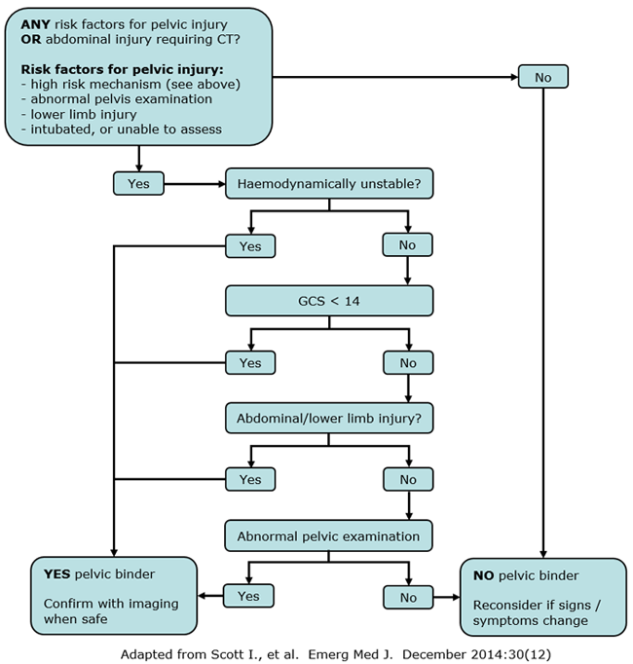

Pelvic binder application
- Apply at level of greater trochanters
- If placed too high over iliac crests, pelvic injury may be exacerbated
- Tie feet together to maintain anatomical position of pelvis (unless there are also lower limb fractures) - figure of eight knot around ankles with bandage or sling

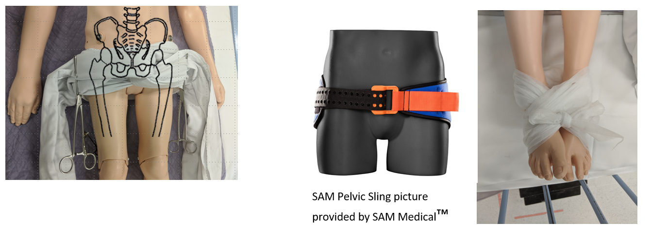

There is little evidence favouring one proprietary binder over another in different age groups. Some binders may be cut to length (e.g. T-POD™, Prometheus Pelvic Splint™), others come in a number of sizes (SAM Pelvic Sling™). Children must have a hip circumference at level of greater trochanters of ≥68 cm (approx 7 years of age) for the smallest SAM Pelvic Sling to be applied; if unsure, first attempt SAM Pelvic Sling application and switch for a sheet if too big
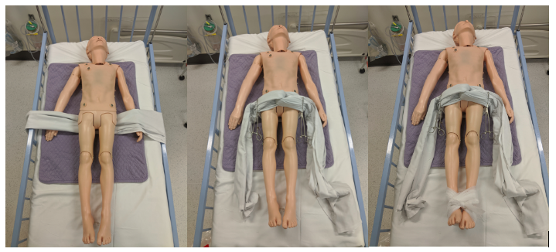

If child is too small for a proprietary binder, use circumferential pelvic sheets:
- Place folded sheet under child at the level of the greater trochanters
- Cross and twist the ends of the sheet over the pubic symphysis
- 2 team members pull the sheet firmly, aiming to distribute force evenly over greater trochanters – take care to brace the patient so they are not moved unnecessarily
- Twist ends together and secure with a clamp where possible (NB plastic clamps are preferable if available - metal clamps can obscure X-rays and CT)

Investigations
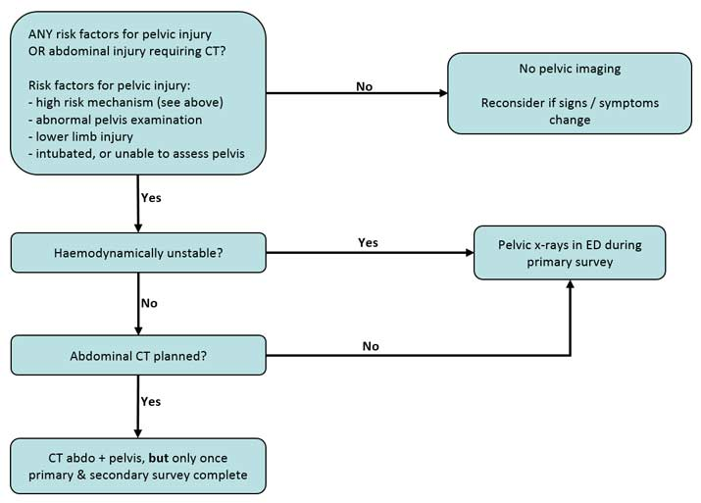
Pelvic binder removal
- In a child with identified unstable pelvic fracture, binder should typically remain in place until definitive stabilisation procedure. On occasion the binder may worsen haemodynamic instability by increasing distraction at the fracture site (e.g. lateral compression fractures) – following urgent consultation with orthopaedics and senior emergency department oversight, the binder may be removed to assist with haemorrhage control.
- Children need careful monitoring for deterioration on removal of pelvic binder – typically in an area capable of providing resuscitation. An unstable fracture can be fully reduced by the binder, causing it not to be seen on xray or CT. If deterioration occurs, reapplication of the binder and further imaging may be required. Where concerns persist despite normal imaging, consider a repeat x-ray (in an area capable of resuscitation – such as the trauma bay) with the binder removed. This should be done in consultation with orthopaedics.
- Binders may cause abrasions and pressure sores and should be removed at earliest opportunity
- Where a pelvic fracture has been identified, consult paediatric surgery or orthopaedic team before removal

